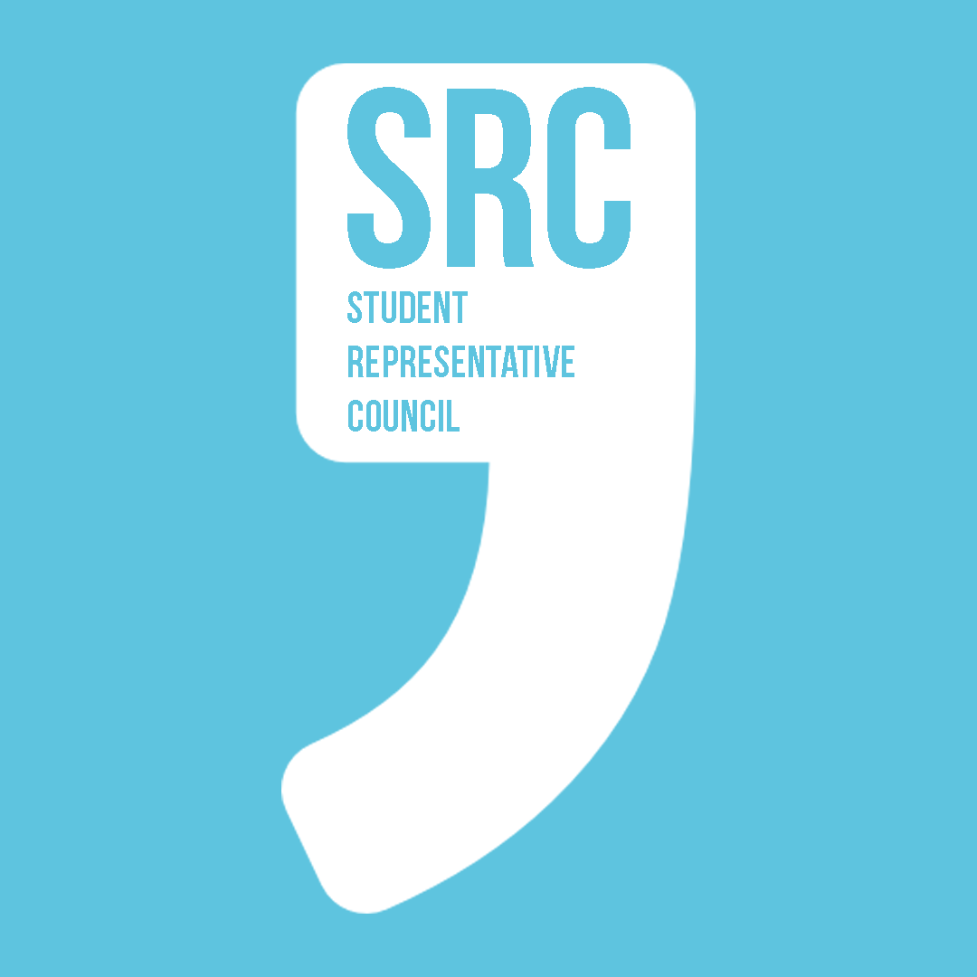

**Paper Title: DUSA’s position on UCU Strikes**

**Date: 12/01/2023**

**Author/proposer: Eamonn Custance**

**Position: General Representative**

**Seconder/s: André Costa**

**Position/s: Environment and Sustainability**

**Introduction:**

The charitable objectives of DUSA that this motion relates to are:

1. The prevention or relief of poverty  
2. The advancement of education  
3. The advancement of health  
4. The advancement of citizenship or community development  
5. The advancement of the arts, heritage, culture or science  
6. The advancement of public participation in sport  
7. The provision of recreational facilities, or the organisation of recreational  
activities, with the object of improving the conditions of life for the persons  
for whom the facilities or activities are primarily intended  
8. The promotion of equality and diversity  
9. The relief of those in need by reason of age, ill health, disability,  
financial hardship or other disadvantage.

On 12/01/2023, the University and Colleges Union (UCU), which represents academic and some technical staff across UK universities, announced 18 days of strike action across February and March as well as a marking and assessment boycott starting in April. The exact dates of the strike will be confirmed shortly before our January SRC meeting. This is part of a long-running dispute starting in 2018 over multiple issues including pay, workload, gender and racial pay gaps, and pension cuts. The current strike is on pay and conditions and pensions cuts. UCU struck for 3 days in the last term. It struck for 13 days in 2021/2. Furthermore, Action Short of Strike (ASOS) has been active since 23rd November, which calls on staff to strictly work to contract, not cover or reschedule for strike days and not undertake voluntary activities. [https://www.ucu.org.uk/article/12680/Universities-to-be-hit-with-18-days-of-strike-action-before-April]

Due to the Trade Union Act 2016, trade unions must use paper ballots and must achieve high turnouts and Yes votes to go on strike. UCU has successfully achieved both, locally and nationally, demonstrating the very clear position of their members.

Separately, both UNISON and Unite, which represent many non-academic staff at our university, have been on strike this year. Unite was on strike continuously for 3 months from August 25th 2022, an exceptionally long strike. This motion does not address these particular local disputes.

University managements negotiate collectively with campus trade unions through the University and Colleges Employers Association (UCEA). UCEA has most recently offered a pay rise far below the rate of inflation just for this year – i.e. a pay cut. UCU has rejected this offer and proceeded with its planned strike.

Out of 19 Scottish University student associations and unions, 10 have publicly posted support for UCU since they announced industrial action last November. This includes Abertay, Edinburgh, Edinburgh Napier, Glasgow, Glasgow Caledonian, Heriot-Watt, Open University in Scotland, St. Andrews, Strathclyde and Stirling. Those who, as of 12/01/2023, have not made any statement, are Aberdeen, Dundee, Glasgow School of Art, Robert Gordon, Royal Conservatoire of Scotland, Queen Margaret, Scotland’s Rural College [which is represented by EIS not UCU], the University of the Highlands and Islands, and the University of the West of Scotland. No Scottish student union has come out against strikes. Furthermore, both the National Union of Students and NUS Scotland publicly support the strikes. I have not checked colleges’ positions.

This motion directs DUSA to support the UCU strikes publicly. It mandates specific action to be taken by DUSA.

**General Information:**

The long-running dispute between UCU and university managements is in the context of an effective real-term pay cut of nearly 25% since 2009. [https://www.ucu.org.uk/article/12469/#Why_are_we_taking_action_on_pay_when_the_employers_have_offered_a_3%_pay_rise?_] Increasing workloads and decreasing pay are causing a significant decline in working conditions for academics, especially those without permanent contracts. As the National Union of Students has said, our lecturers’ working conditions are our learning conditions. It is in our interests that lecturers are properly paid for their work and that the higher education sector as a whole is sustainable, especially in promoting a healthy environment for academics to stay in work.

Trade unions use strikes as a tactic of last resort when negotiations fail. Striking employees are not paid. The University deducts pay at a rate of 1/365 annual salary per day of strike. UCU has a hardship fund which strikers can access. UCU has democratically-elected negotiators and regular meetings with employers both locally and nationally on issues of employment rights, working conditions and pay. It is the intransigence of employers that is causing the strike.

Some courses will be more affected than others by the strike depending on UCU membership across particular schools and divisions. Some courses may see no impact while others will see their entire teaching staff on strike. It is nobody’s first choice for strikes to happen. Certainly not managements, not staff themselves who lose out financially whilst striking, not students who may miss out on their education and have grades delayed, especially for final-year students who will graduate this year. However, UCU has decided it is necessary to strike to protect not only their livelihoods but the sustainability of being an academic for future entrants into the higher education sector. Their strike is therefore in the long-term interests of students and the disruption which a strike causes is justified.

It should also be noted that some students have teaching responsibilities within the university and may themselves be UCU members who may be striking. DUSA has a particular responsibility to represent them as well. From a previous Freedom of Information request I have made, the University does not have a figure for how many students have teaching responsibilities at our University, so it is hard to say how many this applies to.

The university has prior to previous industrial action emailed all students and staff with their position on the strikes. It is therefore perfectly acceptable for DUSA to do so as well.

Immediately after our December meeting, I emailed the executive with a question regarding their position on strikes and inquired whether they would like to bring a policy to the next SRC meeting or alternatively have one presented for them. As is this likely to be the last meeting before strikes recommence I am presenting this now for the SRC to decide so that any policy can be effective before strikes occur.

Some student unions have decided their stance on strikes by precedent on previous strikes, some have held a referendum to decide the issue, some have been decided by their student council or parliament, some have been unilaterally decided by their executive and some have made no stance at all. The motion would decide DUSA’s policy and mandate DUSA to support the strikes.

It is possible that UCEA will make a further acceptable offer to UCU. If UCU were to accept that deal, industrial action may be called off. The best result for everybody would be for UCEA to make an acceptable offer to the campus unions which negates the need for strikes. Unfortunately, due to entrenched opposition by employers, this looks unlikely.

The DUSA Constitution states the SRC can recommend policy for the Board of Trustees [6]; the bye-laws state the SRC can set or direct the Association’s policy [Bye law 2, 3.1.i], to hold both the Board of Trustees and Executive to account [Bye law 2, 3.1.ii]. Accordingly, the motion directs DUSA, the executive and the Trustees to enact specific policies in the interests of students.

Specific: Mandates DUSA to take specific action to support the strike.

Measurable: Public statements and observable activity by DUSA.

Attainable: Other student unions and associations do what this motion proposes.

Relevant: Self-evidently relevant.

Time-based: Some immediately actionable activity – some ongoing commitment for the duration of industrial action which may continue throughout and beyond the summer.

Strengths: An extremely current issue with high profile on campus and nationally of immediate interest to students.

Weaknesses: Previous student engagement with strikes has been confined to a small number of students, any action DUSA takes may not interest many students.

Opportunities: Engaging students with the question of how the university is run.

Threats: Opposition from students who do not support the strike; opposition from the university management; opposition from DUSA/executive or a refusal to implement the motion.

Further information:

https://www.ucu.org.uk/article/12680/Universities-to-be-hit-with-18-days-of-strike-action-before-April

https://www.ucea.ac.uk/news-releases/10jan23/

https://www.dundee.ac.uk/corporate-information/information-industrial-action

https://en.wikipedia.org/wiki/2018%E2%80%932022_UK_higher_education_strikes

https://www.nus.org.uk/nus_uk_response_to_ucu_strikes_announcement

**Conclusion:**

1) SRC believes that the UCU strikes can be averted by university managements offering an acceptable compromise to campus unions and, in the absence of an acceptable deal, supports the strikes as being in the long term interests of students and the higher education sector as a whole.

2) SRC directs DUSA to publicly support the strikes using all its available media both physical and digital; directs the executive to meet with Dundee UCU and students interested in supporting the strike to discuss and agree action on supporting the UCU strike; to email all students ahead of the strike providing information about the strike, DUSA’s position on the strike and advice for students about how they can, if they wish, support the strike; directs the executive to regularly attend the UCU picket line; directs the President to raise the issue of the strike and industrial action at Court and to update the SRC on the response from Court.

3) SRC directs DUSA to raise with the University Executive Group the issue of strikes and to urge them to put pressure on UCEA to avert the strikes by offering the campus trade unions an acceptable deal; this should be in writing, with the letter and response placed on the DUSA website.

4) SRC inquires what the external Trustees of DUSA are doing regarding the strikes and invites them to individually write to the SRC to update us on their work on this issue.

**Legacy Timeline:**

1) February and March SRC meetings can be given an update by the exec or by invited UCU members on the work DUSA has done regarding the strike.

**Appendix:**

LIST OF SCOTTISH STUDENT UNIONS POSITIONS ON THE STRIKES

National Union of Students UK

<https://www.nus.org.uk/nus_uk_response_to_ucu_strikes_announcement>

National Union of Students Scotland

https://twitter.com/NUSScotland/status/1590038314194980864

Edinburgh University – support, following SRC motion 2021. <https://www.eusa.ed.ac.uk/news/article/IndustrialAction2022>

<https://www.eusa.ed.ac.uk/about/policy/academic/industrialaction2019>

“If you are concerned about the loss of teaching, and want to see an end to industrial action, we would encourage you to contact the [University’s Senior Leadership Team](https://www.ed.ac.uk/principals-office) and ask them to meaningfully engage with UCU and their concerns.”

Edinburgh Napier – support.

<https://www.napierstudents.com/news/article/6013/ENSA-Leadership-Statement-on-Proposed-Strike-Action/>

Heriott-Watt – support, following motion at AGM.

<https://www.hwunion.com/news/article/societies/Staff-Strikes/>

Glasgow uni SRC – support, following SRC vote.

<https://www.glasgowunisrc.org/news/article/gusrc/We-Support-the-UCU-Strikes-Nov-22/>

Cap Student Numbers Now campaign

“If you would like to submit a complaint to the University with regards to the strike action taking place, the SRC Advice Centre have some advice on the University's Complaints procedure here: <https://www.glasgowunisrc.org/advice/academic/complaints/> or you may reach out to [the SRC Advice Centre](https://www.glasgowunisrc.org/advice/about/) for assistance with submitting your complaint.”

Glasgow Caledonian University – support, pending policy to Student Voice.

<https://www.gcustudents.co.uk/articles/we-support-strike-action-at-gcu>

Strathclyde – support, exec claims mandate.

<https://www.strathunion.com/news/article/strathunion/UCU-Strikes-Student-Exec-Statement/>

“In addition to the statement of support, we offer the use of the Students’ Union for staff on strike days and have organised free tea and filter coffee at Common Ground for staff on the picket lines across the days of action.”

But also student parliament voted down 54-46% a motion on totally supporting strikes so /shrug

Abertay – support, following SRC vote.

<https://www.abertaysa.com/articles/students-association-support-of-november-ucu-strike-action>

St. Andrew’s – support, following SRC vote.

<https://www.yourunion.net/news/article/9170/UCU-Strikes-November-2023/>

“According to the [St Andrews UCU Branch](https://www.ucustandrews.org/strike), students are encouraged to:

* Sign up to [support the strikes](https://www.ucu.org.uk/supportthestrikes)
* Share your support on social media ([UCU social media resources](https://www.ucu.org.uk/article/12475/Resources) #UCUrising)
* Email the principal (download the [template for current students here](https://www.ucustandrews.org/s/UCUStA_StudentsTemplate.docx))
* Send messages of support and solidarity to University staff!
* Come say hi on the pickets!”

Stirling – support, following General meeting vote.

<https://www.stirlingstudentsunion.com/news/article/6013/Union-statement-on-UCU-strikes/>

Open University – support.

<https://www.oustudents.com/news/article/6013/Student-Leadership-Team-Statement-regarding-outcome-of-strike-ballot/>

Glasgow School of Art – Nothing Yet

Scotland’s Rural College – Nothing Yet

Queen Margaret Uni, Edinburgh – Advertised public meeting with local UCU branch for students

Robert Gordon Uni – Nothing Yet

Royal Conservatoire of Scotland – Nothing Yet

Aberdeen – Nothing Yet

Uni of Highlands and Islands – Nothing Yet

Uni of the West of Scotland – Nothing Yet

Dundee – Nothing Yet.